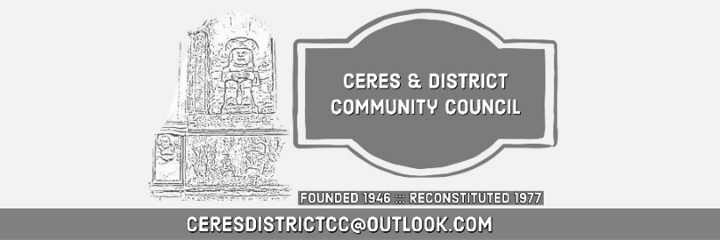
Ceres and District Community Council
(draft) Minutes of the Meeting Monday 11 May 2026
Craigrothie Village Hall

- Present: Moira Henderson, Alistair Ewan, David Beveridge, Neil Martin, Cllr John Caffrey, Cllr Margaret Kennedy ( on line via zoom) , PC Duncan Shand, Hillay Lumsden, 4 Members of the public
- Apologies: Jeremy Baker

Welcome / Apologies / Chair Introduction:
- The Chair welcomed all attendees to the public meeting, both in the Craigrothie Village Hall and on Zoom, and noted the apologies as received. (Jeremy Baker)
- The Chair congratulated the Craigrothie Village Hall for the work on the Hall and the fundraising.

Expenditure of the CC
- An Email from Fife Council has asked for a breakdown of the community council accounts
- CC does no take expenses for printing etc or travel. This also was highlighted at the last group meeting of CC’s
- Clr Caffrey took an action to find out who to query in Fife Council regarding what are allowable expenses for a Community Council. (A)

Police Matters
- PC Duncan Shand was in attendance. He gave an overview of changes that have occurred with Policing in Fife.
- It was highlighted that a dog off the lead in a field with sheep is a criminal offence. This will be publicized and PC Shand will provide some words to help with this. (A)
- Sergeant Mike Wishart Cupar Police station is responsible for Ceres & District

Traffic Matters
- There was a discussion on speeding Ceres/Craigrothie and Chance Inn
- Ceres now has 2 speed humps at school, cost of 2nd hump escalated due to required drainage installation.
- Lines at the Craigrothie crossing/speed hump next to school to be extended to both sides, a box is to be painted for the bus stop to restrict parking. Both actions intended to improve visibility of pedestrians.

Ceres Memorial Hall
  - Ceres Hall - have completed installation of solar panels & battery
  - Thanks to the Trust for all their work.

Ceres and District Trust Update
  - Alistair Ewan gave an overview
    - Bridge to Glebe completed end of Feb
    - Funded by Fife Rural Development Fund
  - Applied for funding to put new fences up at Glebe
  - Plan for a peace garden
    - Peter Christopher - doing garden design
  - Reminder that Ceres Highland Games is the 27th of May 2026
- Trees removed at the Bow Butts were diseased (Maple and Ash) Fife council looking from recommendations for replacement species. Chestnut was floated as a possibility. Public welcome to comment

Save Elmwood Campus
Hillary Lumsden spoke, looking in support of the Save Elmwood Campus.group.
Elmwood has provided education, training and opportunity in North East Fife since the 1950s. Over generations, it has developed strong links with the local community, supported the rural economy, and helped thousands of students gain practical skills, qualifications and careers connected to Scotland’s land-based industries.

The Save Elmwood campaign believes Elmwood’s future should continue to reflect that legacy. Our vision is to use Elmwood’s heritage, facilities and community value to help create a collaborative, sustainable and locally rooted space that supports education, skills, enterprise and opportunity for the people of Cupar and North East Fife.

We plan to call for commitment to the following principle:
Any future capital receipt arising from the sale or disposal of land or assets at the Elmwood site should remain within North East Fife and be ringfenced solely for local educational and community benefit purposes, including education, skills, training and community learning provision in the area. Given that these assets were originally transferred for public educational benefit, there is a strong case that any proceeds should be returned to the area through a dedicated local education or community trust, rather than being absorbed into central institutional finances or redirected elsewhere.

Local Authority and Planning
- Specific planning applications:
- Craigrothie - Substitution of house type (amendment to 24/03285/ARC)
- Decision 18th May 2026
- This is the application for conversion to domestic house for Steve Simpson, repeating the process as there were problems with the original application.
- Alistair Ewan raised the issue of the crossing at the Baltilly development. Clr Caffrey took an action to request that the developer put in a raised platform for the crossing as it close to the start of the 20 MPH zone and would then be consistent with the other roads in Ceres. (A)

The Meeting Ended: 9:00pm
Next Public Meeting: AGM - Monday the 13 July 2026

